1. Camel provides a lot of **Enterprise Integration Patterns**.
2. **Agenda**:
   1. Some Integration Patterns most commonly used.

### Pipeline Pattern

1. Default Pattern.
2. Till now we’re using this pattern.
3. in the below snapshot, ignore the choice() part. See the 2nd snapshot for more clarity where we have multiple channels. 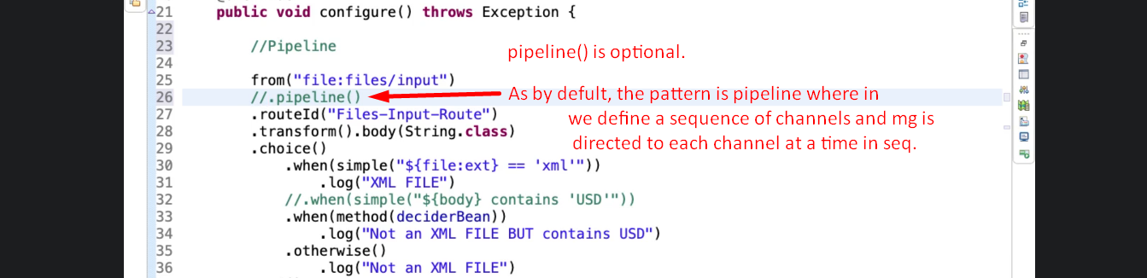  
     
   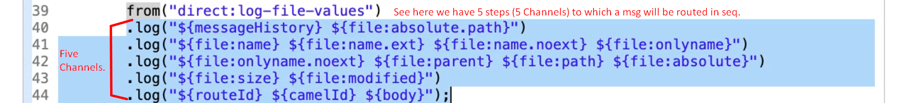

### Content Based Routing

1. Text, application

   Description automatically generated
2. We can actually look at the extension of the msg or a particular header of the msg and the accordingly we can route it to a particular channel.

### 

### Multicast Pattern

1. Let’s create a new file to understand this pattern.
2. Graphical user interface, application

   Description automatically generatedEach of the processors or endpoints (Line#14) will get a copy of the original msg.  
   **Output**:  
   